HTML Encoding

📘 Definition
# Source: AI Source: Provided by: [Data Path: Persons Table -> ID Column: 1, Name_En Column: Motasem Essam] -> From: [ChatGPT] on [5/6/2026]
HTML encoding defines how characters (letters, symbols, emojis, languages) are stored and displayed correctly in a webpage.

🔐 HTML Encoding Types

1. Windows-1252
# Source: AI Source: Provided by: [Data Path: Persons Table -> ID Column: 1, Name_En Column: Motasem Essam] -> From: [ChatGPT] on [5/6/2026]
📖 Description
Used in older Windows systems, similar to ISO-8859-1 but with extra symbols like €.
💻 Example:
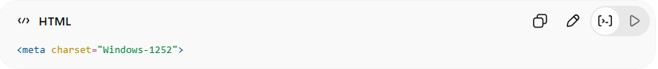
<meta charset="Windows-1252">
✔ Supports some extra symbols
❌ Not modern standard

2. ASCII (Basic Encoding)
# Source: AI Source: Provided by: [Data Path: Persons Table -> ID Column: 1, Name_En Column: Motasem Essam] -> From: [ChatGPT] on [5/6/2026]
📖 Description
Oldest encoding system, supports only basic English letters.
💻 Example:
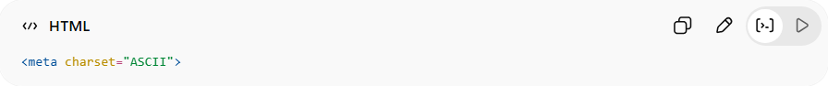
<meta charset="ASCII">
✔ Simple system
❌ Only 128 characters
❌ No accents, symbols, or other languages

3. ISO-8859-1 (Latin-1)
# Source: AI Source: Provided by: [Data Path: Persons Table -> ID Column: 1, Name_En Column: Motasem Essam] -> From: [ChatGPT] on [5/6/2026]
📖 Description
Old encoding for Western European languages only.
💻 Example:
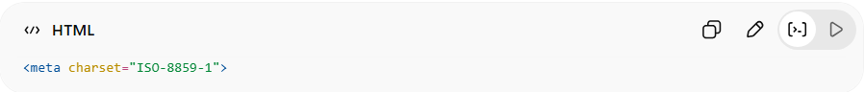
<meta charset="ISO-8859-1">
❌ Limited characters
❌ No full Unicode support

4. UTF-8 (Standard Encoding)
# Source: AI Source: Provided by: [Data Path: Persons Table -> ID Column: 1, Name_En Column: Motasem Essam] -> From: [ChatGPT] on [5/6/2026]
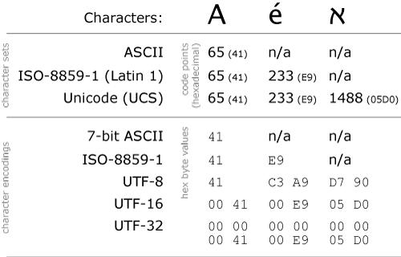
📖 Description
The most used encoding in the world that supports all languages and emojis.
💻 Example:
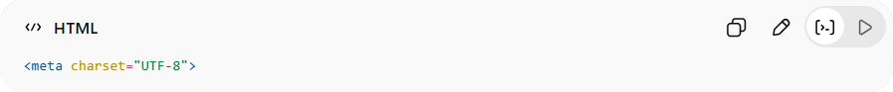
<meta charset="UTF-8">
✔ Supports all languages
✔ Supports emojis 😀
✔ Best for all websites

5. UTF-16
# Source: AI Source: Provided by: [Data Path: Persons Table -> ID Column: 1, Name_En Column: Motasem Essam] -> From: [ChatGPT] on [5/6/2026]
📖 Description
Supports all Unicode characters but uses more memory.
💻 Example:
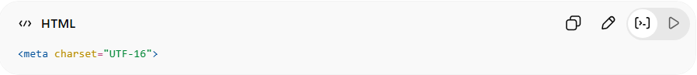
<meta charset="UTF-16">
✔ Full language support
❌ Larger file size
❌ Less common for websites

6. UTF-32
# Source: AI Source: Provided by: [Data Path: Persons Table -> ID Column: 1, Name_En Column: Motasem Essam] -> From: [ChatGPT] on [5/6/2026]
📖 Description
Encoding where each character uses 4 bytes (fixed size), making it very simple but inefficient.
💻 Example:
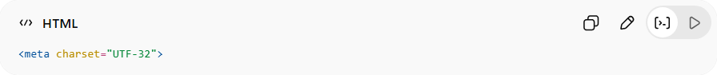
<meta charset="UTF-32">
✔ Very simple structure (fixed length per character)
✔ Supports all Unicode characters
❌ Very large file size
❌ Rarely used on the web (not efficient)

⚖️ Encoding Comparison
# Source: AI Source: Provided by: [Data Path: Persons Table -> ID Column: 1, Name_En Column: Motasem Essam] -> From: [ChatGPT] on [5/6/2026]
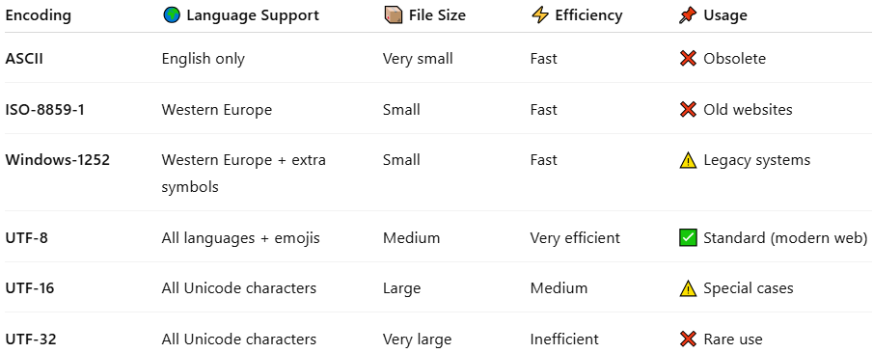
Encoding | 🌍 Language Support | 📦 File Size | ⚡ Efficiency | 📌 Usage
ASCII | English only | Very small | Fast | ❌ Obsolete
ISO-8859-1 | Western Europe | Small | Fast | ❌ Old websites
Windows-1252 | Western Europe + extra symbols | Small | Fast | ⚠️ Legacy systems
UTF-8 | All languages + emojis | Medium | Very efficient | ✅ Standard (modern web)
UTF-16 | All Unicode characters | Large | Medium | ⚠️ Special cases
UTF-32 | All Unicode characters | Very large | Inefficient | ❌ Rare use

📘 Best Practice
# Source: AI Source: Provided by: [Data Path: Persons Table -> ID Column: 1, Name_En Column: Motasem Essam] -> From: [ChatGPT] on [5/6/2026]
The best practice for HTML encoding is:
✔ Always use UTF-8 encoding in every HTML document

Why UTF-8 is the best?
# Source: AI Source: Provided by: [Data Path: Persons Table -> ID Column: 1, Name_En Column: Motasem Essam] -> From: [ChatGPT] on [5/6/2026]
🌍 1. Supports ALL languages
- English 🇬🇧
- Arabic 🇪🇬
- Chinese 🇨🇳
- Emojis 😀
🌐 2. Works on all browsers
- Chrome
- Firefox
- Edge
- Safari
⚡ 3. Prevents text errors
- No broken symbols (???)
- No corrupted text
- No missing characters
📱 4. Mobile + Web friendly
- Works on all devices
- Responsive and modern standard

Why UTF-16 and UTF-32 are NOT the best for HTML web pages
# Source: AI Source: Provided by: [Data Path: Persons Table -> ID Column: 1, Name_En Column: Motasem Essam] -> From: [ChatGPT] on [5/6/2026]
Even though UTF-16 and UTF-32 support all languages, they are not optimized for the web.
📖 1. Uses more memory than UTF-8
- Characters use 2 or 4 bytes
- English text becomes larger compared to UTF-8
👉 Result: bigger files, slower loading
📖 2. Not web-friendly by default
- Not designed for URLs, HTML, and web transport
- Can cause compatibility issues in some tools
📖 3. Less efficient for common web text
- Most websites are mostly English + symbols
- UTF-8 uses 1 byte for common English letters
- UTF-16 uses more space unnecessarily
UTF-32 — Why it’s even worse for web
📖 1. Very large file size
- Every character = 4 bytes (fixed)
- Even simple text becomes huge
👉 Example:
- “Hello” = 5 characters → 20 bytes
📖 2. Wastes storage & bandwidth
- Slow page loading
- Higher server costs
- More internet data usage
📖 3. Rarely supported in web systems
- Browsers and web tools do NOT prefer it
- Mostly used in internal systems or research, not websites

Why UTF-8 is better than both
# Source: AI Source: Provided by: [Data Path: Persons Table -> ID Column: 1, Name_En Column: Motasem Essam] -> From: [ChatGPT] on [5/6/2026]
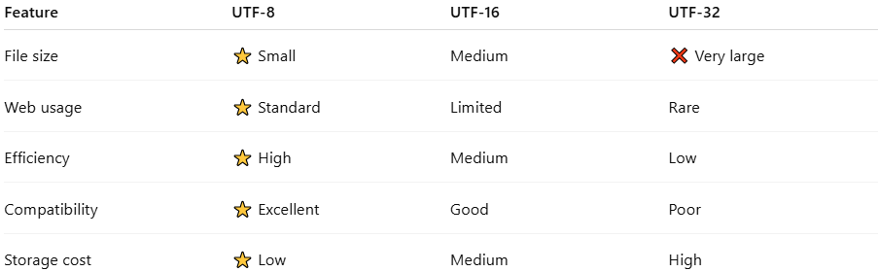
Feature | UTF-8 | UTF-16 | UTF-32
File size | ⭐ Small | Medium | ❌ Very large
Web usage | ⭐ Standard | Limited | Rare
Efficiency | ⭐ High | Medium | Low
Compatibility | ⭐ Excellent | Good | Poor
Storage cost | ⭐ Low | Medium | High

Conclusion
👉 UTF-16 is heavier than UTF-8 and not ideal for web speed
👉 UTF-32 is too large and inefficient for real websites
🟢 Best choice:
✔ UTF-8 is the global standard because it is fast, small, and fully compatible with the web

When to Use UTF-16 and UTF-32
# Source: AI Source: Provided by: [Data Path: Persons Table -> ID Column: 1, Name_En Column: Motasem Essam] -> From: [ChatGPT] on [5/6/2026]
Even though UTF-8 is the standard for HTML, UTF-16 and UTF-32 still have limited special use cases.

🟡 When to use UTF-16 in web
# Source: AI Source: Provided by: [Data Path: Persons Table -> ID Column: 1, Name_En Column: Motasem Essam] -> From: [ChatGPT] on [5/6/2026]
📖 1. XML Documents (sometimes)
- Some XML systems may use UTF-16
<?xml version="1.0" encoding="UTF-16"?>
👉 Used in older or enterprise systems
📖 2. Internal browser memory (important!)
- Browsers like Chrome/Firefox often store JavaScript strings internally as UTF-16
👉 But this is not for HTML files, only internal processing
📖 3. Legacy systems or APIs
- Some old systems still require UTF-16 for compatibility

🔴 When NOT to use UTF-16 in web
# Source: AI Source: Provided by: [Data Path: Persons Table -> ID Column: 1, Name_En Column: Motasem Essam] -> From: [ChatGPT] on [5/6/2026]
- ❌ HTML pages
- ❌ CSS files
- ❌ JavaScript files served to browser
- ❌ Modern websites
👉 Because it increases file size and slows loading

🟣 When to use UTF-32 in web
# Source: AI Source: Provided by: [Data Path: Persons Table -> ID Column: 1, Name_En Column: Motasem Essam] -> From: [ChatGPT] on [5/6/2026]
📖 1. Rare internal systems (not web pages)
- Used in some scientific or research software
📖 2. Fixed-length character processing
- Every character = 4 bytes
- Makes processing very simple for algorithms
📖 3. Internal computing or experiments
- Used in:
  - Language research tools
  - Encoding experiments
  - Some OS-level processing

🔴 When NOT to use UTF-32 in web
# Source: AI Source: Provided by: [Data Path: Persons Table -> ID Column: 1, Name_En Column: Motasem Essam] -> From: [ChatGPT] on [5/6/2026]
- ❌ Websites
- ❌ HTML documents
- ❌ APIs for browsers
- ❌ Mobile apps web content
👉 Because it is too large and slow

⚖️ Summary
# Source: AI Source: Provided by: [Data Path: Persons Table -> ID Column: 1, Name_En Column: Motasem Essam] -> From: [ChatGPT] on [5/6/2026]
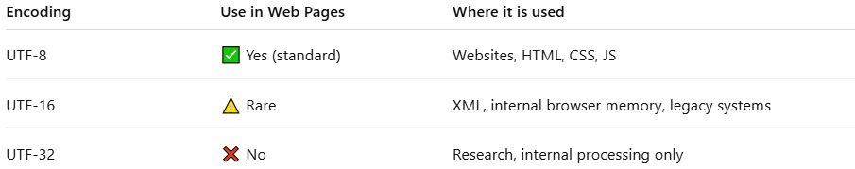
Encoding | Use in Web Pages | Where it is used
UTF-8 | ✅ Yes (standard) | Websites, HTML, CSS, JS
UTF-16 | ⚠️ Rare | XML, internal browser memory, legacy systems
UTF-32 | ❌ No | Research, internal processing only

🚀 Final Conclusion
- 🟢 UTF-8 = for all web pages (BEST choice)
- 🟡 UTF-16 = rare legacy or internal systems
- 🔴 UTF-32 = not used in web development (too heavy)

🚀 Summary
# Source: AI Source: Provided by: [Data Path: Persons Table -> ID Column: 1, Name_En Column: Motasem Essam] -> From: [ChatGPT] on [5/6/2026]
HTML Encoding = system that tells the browser how to display text correctly.
👉 UTF-8 is the modern universal standard used in almost all websites today.

